SWAG CO.
Custom Beanies & MORE
Order Form
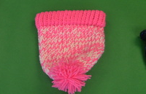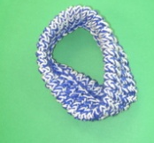
Name___________________________________________
Deliver location (1st period)

Hat Prices:
One color ($8) _____ Two colors ($10) _____ Three colors ($12) _____

Head Band Prices:
One color ($5) _____ Two colors ($8) _____ Three colors ($10) _____

Scarf Prices:
One color ($12) _____ Two colors ($15) _____ Three colors ($17) _____

Circle your color(s)
Red Blue Green Red Pink Brown Black White Yellow Orange Purple Gold
Other colors ________________

Pom poms (For the top of the hat) ($1) ____
Other ideas (ex. Stripes, mix colors) __________________
Check out our commercials for samples and information!
Please make checks payable to Palisades FBLA

